沉默的婆罗浮屠
The Silence of Borobudur
竹笛、 琵琶与民族管弦乐队
for Zhudi, Pipa and Chinese Orchestra

朱一清
Zhu Yiqing

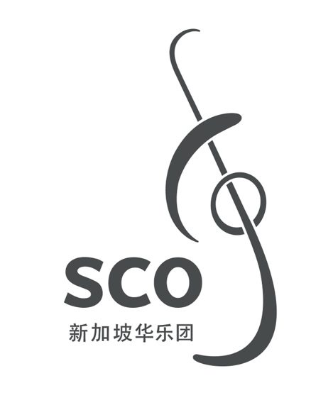

00/000
沉默的婆罗浮屠
The Silence of Borobudur
竹笛、 琵琶与民族管弦乐队
for Zhudi, Pipa and Chinese Orchestra

朱一清
Zhu Yiqing
(2011, rev. 2014)
25' 30''

沉默的婆罗浮屠
The Silence of Borobudur

ISMN

Copyright © Singapore Chinese Orchestra Co. Ltd. All rights reserved.

版权所有, 未经许可, 不得以任何形式印刷、复制、扫描或发行。
Unauthorised printing, reproduction, scanning or distribution is strictly prohibited
without the express permission of the copyright holder.

印刷于新加坡。
Printed in Singapore.

新加坡华乐团有限公司
珊顿道7号
新加坡大会堂
新加坡邮区 068810

Singapore Chinese Orchestra Co. Ltd.
7 Shenton Way
Singapore Conference Hall
Singapore 068810

网站 Website: www.sco.com.sg
电邮 Email: aa@sco.com.sg
电话 Telephone: (65) 6557 4026
传真 Fax: (65) 6557 2756

传Biography
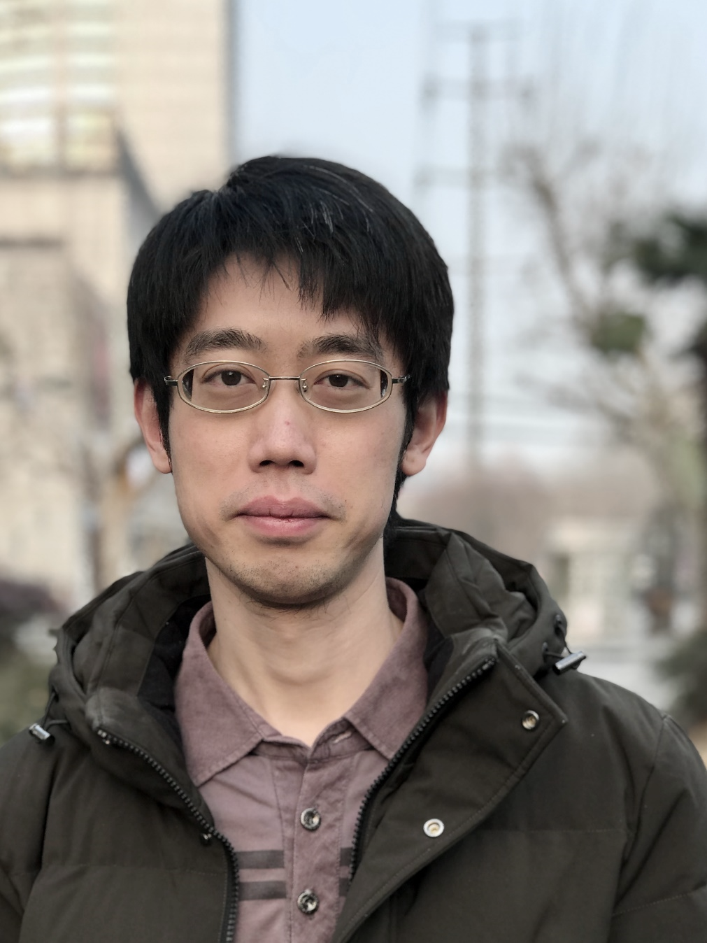
朱⼀清，作曲家，上海⾳乐学院作曲系教师，毕业于上海⾳乐学院和斯图加特⾳乐学院，师从吕⻩、叶国辉、 Niels Rosing-Schow、 Marco Stroppa。朱⼀清于2024年被授予著名的德国“恩斯特·冯·西门子作曲家奖”。他的作品 “DeepGrey” (为交响乐队) 获2021年瑞⼠ 巴塞尔作曲大赛 第⼀⼤奖； “Gigue” (为室内乐) 获2019年意⼤利 Dyce 作曲大赛 的唯⼀⼤奖；三⾸室内乐团与实时电⼦⾳乐作品 “Le ciel écrasé”, “Le visage déchiré”, “White Night” 获2019年奥地利 Impuls 作曲奖。 “The Silence of Borobudur” (⽵笛/琵琶和⺠族管弦乐队) 获2011年 新加坡华乐作曲大赛 第三名。除当代⾳乐之外，他的作品还涵盖了包括世界⾳乐、电⼦⾳乐、电脑⾳乐、流⾏⾳乐、爵⼠摇滚、电影⾳乐、多媒体⾳乐等诸多领域。
他的作品在世界各地被⼴泛上演，并与众多乐团建⽴委约与合作，包括 Ensemble Intercontemporain, Basel Sinfonietta, Singapore Chinese Orchestra, Ensemble Musikfabrik, Ensemble of Lucerne Festival Alumni, Klangforum Wien, Neue Vocalsolisten Stuttgart, Moscow Contemporary Music Ensemble, Mivos Quartet, Quatour Diotima, Divertimento Ensemble, Ensemble U:, Ensemble Cikada, Taller Sonoro, Ensemble xx. Jahrhundert Wien, Ensemble Soundstreams, Ensemble Suono Giallo, Han String Quartet, Ensemble Novel, Studio-C Ensemble, Copenhagen Piano Quartet, China-Asean Contemporary Orchestra, Ensemble Echtzeit, Telegraph Quartet 以及 上海交响乐团、上海爱乐乐团等等

Born in Dec. 1989, Yiqing Zhu is a Chinese composer. He began composing in 2008 at Shanghai Conservatory of Music under the guidance of Prof. Huang Lv and Prof. Guohui Ye; after one year of Erasmus with Prof. Niels Rosing-Schow at The Royal Danish Academy of Music, he continued his study (Konzertexamen) at Stattliche Hochschule für Musik und Darstellende Kunst Stuttgart under the guidance of Prof. Marco Stroppa from 2016 to 2019. Currently, Zhu is the teacher of composition department at Shanghai Conservatory of Music.
As a recipient of the Ernst von Siemens Composers Prize 2024, Zhu's works are widely played throughout Europe and Asia. His piece "DeepGrey" (for orchestra) won the 1st Prize of Basel Composition Competition 2021. He is also the winner of IMPULS Composition Competition 2019 in Graz, Dyce Composition Competition 2019 in Milan and the 3rd Prize winner of Singapore Chinese Orchestra competition 2011. Apart from contemporary music, he also works in the fields of Eastern traditional music, electronic music, computer music, jazz music, film music, world music as well as popular music.
His works were commissioned by various Music Festivals, such as MANIFESTE, ILSUONO contemporary Music Week, LUCERNE Festival, Shanghai New Music Week, Festival ARCHIPEL, DYCE Festival, IMPULS Festival, ACHT BRÜCKEN Festival etc. His music was performed by numerous soloists and, among others, Ensemble Intercontemporain, Basel Sinfonietta, Singapore Chinese Orchestra, Ensemble Musikfabrik, Ensemble of Lucerne Festival Alumni, Klangforum Wien, Neue Vocalsolisten Stuttgart, Moscow Contemporary Music Ensemble, Mivos Quartet, Quatour Diotima, Divertimento Ensemble, Ensemble U, Ensemble Cikada, Taller Sonoro, Ensemble xx. Jarhundert Wien, Ensemble Soundstreams, Ensemble Suono Giallo, Han String Quartet, Ensemble Novel, Studio-C Ensemble, Copenhagen Piano Quartet, China-Asean Contemporary Orchestra, Ensemble Echtzeit, Telegraph Quartet, Shanghai Symphony Orchestra, Shanghai Philharmonic Symphony Orchestra, and more.
乐曲介绍Synopsis
公元919年赛伦德拉王朝被推翻后，婆罗浮屠就不再受到重视，任⻛⾬的剥蚀。公元1006年默拉⽐⽕⼭爆发，这座曾经的修道与朝拜的圣地，便被⽕⼭灰⻓久地掩埋在⿊暗、寂静的尘⼟之下。

The once mighty Mataram Kingdom of Java was declining by the start of the 10th century AD. As it declined, so did Borobudur; its importance to the people waned. In 1006 AD Mount Merapi erupted, burying the holy temple of monasticism and worship under a thick layer of volcanic ash for centuries to come, leaving the place to sit in perpetual silence.
编制Instrumentation
梆笛 Bangdi I, II
曲笛 Qudi
新笛 Xindi I, II
高音笙 Gaoyin Sheng I, II
中音笙 Zhongyin Sheng I, II
低音笙 Diyin Sheng
唢呐/管 I Suona/Guan I: 高音唢呐I Gaoyin Suona I, 高音管 Gaoyin Guan
唢呐II Suona II: 高音唢呐II Gaoyin Suona II
唢呐/管 III Suona/Guan III: 中音唢呐 Zhongyin Suona, 低音管I Diyin Guan I
唢呐/管 IV Suona/Guan IV: 中音唢呐 Zhongyin Suona, 低音唢呐Diyin Suona, 低音管II Diyin Guan II
管 V Guan V: 高音管 Gaoyin Guan, 中音管 Zhongyin Guan

扬琴 Yangqin
柳琴 Liuqin
琵琶 Pipa (4)
中阮 Zhongruan (4)
三弦 Sanxian
大阮 Daruan
古筝 Guzheng
竖琴 Harp

6 打击乐 Percussion
I: (西方) 木鱼 Woodblocks, 钟琴 Glockenspiel, 云锣 Yunluo, 小堂鼓 Xiaotanggu, 排鼓 Paigu, 中国木鱼 Chinese Woodblock
II: 中国木鱼 Chinese Woodblock, 颤音琴 Vibraphone, 大钹 Dabo, 排鼓 Paigu, 军镲 Cymbals, 通通鼓 Tom-toms
III: 木琴 Xylophone, 通通鼓 Tom-toms, 乐鞭 Whip, 康嘎鼓 Congas
IV: 编钟 Bianzhong, 通通鼓 Tom-toms, 马林巴 Marimba, 军镲 Cymbals
V: 铓锣 Mangluo, 颤音琴 Vibraphone, 编钟 Bianzhong, 大军鼓 Bass Drum, 大锣 Daluo
VI: (中国)大鼓 Dagu, 管钟琴 Tubaphone, 小军鼓 Snare Drum, 编磬 Bianqing

竹笛独奏 Zhudi solo
琵琶独奏 Pipa solo

高胡 Gaohu
二胡 Erhu I
二胡 Erhu II
中胡 Zhonghu
大提琴 Violoncello
低音提琴 Contrabass

演奏说明Performance Notes
独奏竹笛 Solo Zhudi:
：稍稍含有气声 (嘴唇稍微离开吹孔，并能够同时听到音高和吹气的噪音)。
〰〰 ：意为气息颤动。
ord. ：正常演奏(ordinary,包括正常的颤动、正常的口唇与吹孔的距离关系等)。
gliss. ：指滑音或气滑音。
vib. ：颤动,颤吟(专指通过气流大小的改变造成,不含指法的变化)
quasi vib. ：十分强烈,甚至有些夸张和乖戾的颤动和颤吟(通过气流大小的改变造成,不含指法的变化)。
non vib. ：没有任何颤动和颤吟。
tr. ：为基础音与其上方小二度的颤音(无论处在什么调性环境下)。

独奏琵琶 Solo Pipa:
- 泛音 Harmonics：
记谱：◯ （泛音音程和泛音和弦同样仅仅使用单个泛音记号表示）。
Overtone notes are also represented by same above circle.
- 独奏琵琶的定弦 Pipa Scordatura：A♭、D、E♭、A
注意：乐谱中所有的音高皆为实际发音音高,不在作缠弦的移位演奏音高记谱处理。
Note: All scordatura pitches in the score are written in sounding pitch.
- 琵琶技巧 Pipa Techniques：
 ：轮指（仅一下） Five finger roll (on a single note)
 ：持续轮指（包括满轮） Continuous five finger roll (across multiple notes)
 ：连续快速弹挑，和震音的意义相同 Continuous roll with strumming (same as tremolo)
: 扫弦（仅一下） Strum (on a single note)
 ：连续扫拂 （“拂”记号省略） Continuous strumming
K : (没有符头的音) 意为绞弦演奏 Twisted strings (Notes without noteheads)

乐队各组乐器 Rest of the orchestra:
- 吹管乐器组 Wind Instruments：
：(air tone) 在相应的音高位置吹奏气声,即:嘴唇稍稍离开吹孔而使一定的气漏出孔外，兼有吹气声和谱面上所标示的具 体音高。Play the air sound at the corresponding pitch, i.e. the lips are positioned slightly away from the mouthpiece to allow a certain amount of air to leak out of the hole. Both the air note and the specific pitch are marked in the score.
〰〰 ：意为气息颤动。Turbulent air.
tr. ：为基础音与其上方小二度的颤音(无论处在什么调性环境下)。Trill. The top note is always a minor second above the fundamental note (regardless of key signature or proceeding accidental).

另注：全曲中,梆笛声部皆使用g调梆笛,曲笛声部皆使用C调曲笛，新笛声部皆使用F调新笛。只有在演奏家认为这三种笛的调门对于 演奏有困难，方可在相应音域内自行安排竹笛的调门。
Important note: Throughout the piece, the Bangdis are tuned in G, the Qudi is tuned in C, and the Xindi in F. The performer may adjust the tuning of their bamboo flute to fit the corresponding range should the passage be too tricky to play.

- 弹拨乐器组 Plucked String Instruments:
 ：轮指（仅一下） Five finger roll (on a single note)
 ：持续轮指（包括满轮） Continuous five finger roll (across multiple notes)
：连续快速弹挑，和震音的意义相同 Continuous roll with strumming (same as tremolo)
: 扫弦（仅一下） Strum (on a single note)
 ：连续扫拂 （“拂”记号省略） Continuous strumming
〰〰 ：意为气息颤动 Turbulent air
泛音：下方实心符头为基础音,中间菱形符头为虚按音,上方实心符头为实际发音。
Overtones: The solid note head at the bottom is the fundamental, the diamond note head above it is the depressed note, and the solid note head at the top is the sounding pitch.
- 打击乐器组 Percussion Instruments:
- Hard stick: 用硬槌
- Medium stick: 用中等硬度的槌
- Soft stick: 用软槌
- Wood stick: 用木质槌
- Tam-tam stick: 用大锣槌
另注：打击乐演奏者2与4的Cymbals、打击乐演奏者3与6的Vibraphone、以及打击乐演奏者2至4的tom-tom皆需准备两件 (套)乐器,并非一件乐器供多人合用演奏。
Note: Cymbals for percussionists 2 and 4, vibraphone for percussionists 2 and 5, and tom-tom for percussionists 2, 3 and 4 all require two instruments (sets). It should not be one instrument for multiple people to play together.
- 拉弦乐器组 String Instruments:
泛音:下方实心符头为基础音,中间菱形符头为虚按音,上方实心符头为实际发音。(实际发音的音高在谱面上或省略)
：极端音高、极限音高 Highest possible pitch
〰〰 ：意为气息颤动 Turbulent air
tr. ：为基础音与其上方小二度的颤音(无论处在什么调性环境下)。Trill. The top note is always a minor second above the fundamental note (regardless of key signature or proceeding accidental).

拉弦乐器组的分声部演奏 String Instrument Divisi Performance Directions:
- 高胡、二胡I、二胡Ⅱ、中胡分为两行谱表时,上方谱表为所在乐器组的第1-4人，下方谱表为第5-7人。大提琴分为两行谱表时，上方谱表为所在乐器组的第1-3人，下方谱表为第4-6人。
If Gaohu, Erhu I, Erhu II, and Zhonghu are divided into two staves, the upper staves are for the 1st to 4th players in their instrument group, and the lower staves are for the 5th to 7th players. If the violoncello is divided into two staves, the upper staves are for the 1st to 3rd players in the instrument group, and the lower staves are for the 4th to 6th players.
- 当高胡、二胡I、二胡II、中胡各分为七个声部、大提琴分为六个声部时,所有声部皆由单独的演奏家演奏。
If Gaohu, Erhu I, Erhu II, and Zhonghu are divided into seven parts each, and the violoncello is divided into six parts, all parts are played independently.
- 当高胡、二胡I、二胡Ⅱ、中胡被分为两行谱表,并且每种乐器的第一行谱表(第1-4人)分为两步演奏时,第1-2人演奏第一声部，第3-4人演奏第二声部。
If Gaohu, Erhu I, Erhu II, and Zhonghu are divided into two staves, and the first upper stave itself is further divided (i.e. div. a 2), the 1st to 2nd persons play the top voice, and 3rd to 4th persons play the bottom voice.
- 当高胡、二胡I、二胡Ⅱ、中胡没有细分两行谱表时,若分为两部演奏,则由第1-4人演奏第一声部,由第5-7人演奏第二声部。当大提琴没有细分两行谱表时，若分两部演奏，则则由第1-3人演奏第一声部,由第4-6人演奏第二声部。
If Gaohu, Erhu I, Erhu II, and Zhonghu do not have two lines of staves, and they are played divisi, the 1st to 4th person will the top voice, and the 5th to 7th person will play the bottom voice. If violoncello does not have two lines of staves, if they are played in two parts, the 1st to 3rd person will play the upper voice, and the 4th to 6th person will play the second part.

